Functional Interface Sub-Interface

Emergency brake EVC EB (BIU)

Air Gap Interface beacons EVC (BTM)

Air Gap Interface loops EVC (LTM)

Air Gap Interface Radio EVC (Radio-RBC)

Train motion EVC Odometrie (ODO)

Cab selection Desk state (TIU)

Traction cut-off Desk state (TIU)

Driving direction Direction controller state (TIU)

Traction cut-off Tractioin cut-off (TIU)

Service brake Service brake (TIU)*

Sleeping & Non Leading Sleeping (TIU)

Power Supply Power supply

Isolation EVC Isolation, STM Isolation (TIU)

Driver DMI Display (DMI)

Maintenance TRU

Other functions ZSG, AFB (ICE Germany) (TIU)

Juridical data storage (JRU)

Diagnose data storage (DRU)

Class B systems (STM)

Installation requirements

1.2 Interface with the emergency brake

1.2.1 There shall tow independent ERTMS emergency brake commands in the trainset.

1.2.2 The ERTMS equipment shall control that the command of the emergency brakes is
correctly to the train interface.

1.2.3 Emergency brake command shall be tested during the daily test.

1.5 Cab selection

1.6.1 Train Body shall provide the cab selection information to the EVC.

1.6 Driving direction

1.6.1 The Train body shall provide driving direction information to the EVC.

1.6.2 The ERTMS equipment shall read the driving direction via the Direction Controller State
Interface.

1.6.3 The ERTMS shall implement a standstill supervision to avoid a movement of the trainset
Without direction selected. This is a specified ETCS function (see roll away protection)

1.7 Interface with traction cut-off

    - ERTMS System shall provide the traction cut-off This is a specified ETCS function (see roll away protection)

    - Train Body (TIU) shall provide the feedback from the traction cut off system

    - ERTMS function shall command a software traction cut-off via the Traction cut-off Interface of the EVC equipment.

    - When ERTMS emergency brakes are applied, when the traction cut off is requested and a low pressure I detected in the main EB pipe, than it is the responsibility of the train driver to cut the traction.

  - Interface service brake

    - The ERTMS function shall controll the service brake via the Service Brake in interface of the EVC (TIU).

    - Monitoring of the Service brake shall be performed by the combination of the Service Brake state and the Odometry declaration (It is an internal function of the EVC).

    - In case of simultaneous service brake and emergency brake request, the priority shall be given to the emergency brake.

  - Interface with sleeping

    - Train Body (TIU) shall provide the sleeping information to the EVC.

    - The ERTMS shall detect the request to enter in sleeping mode via the Sleeping
interface.

    - Train Body (TIU) shall provide the feedback from the traction cut off system

    - ERTMS function shall command a software traction cut-off via the Traction cut-off Interface of the EVC equipment.

    - When ERTMS emergency brakes are applied, when the traction cut off is requested and a low pressure I detected in the main EB pipe, than it is the responsibility of the train driver to cut the traction.

  - Interface with power supply (not relevant for the SSRS)

    - To be able to manage the sleeping mode, the ERTMS equipment shall be allways
Powered as soon as the train is powered.

    - If longer operation is needed, the driver shall be able to perform a power off/power on sequence to restart the system before exceeding 24 hours.

    - Driver shall not use circuit breakers or ERTMS isolation under normal circumstances.

  - Interface with ETCS Isolation (not relevant for the SSRS)

    - The ERTMS equipment shall be interfaced to an isolation switch. When the equipment is isolated, it shall no more be powered, and no more able to apply the emergency brake.

National DMI requirements

  - Interface with the Driver/DMI

    - The driver shall interact with the ERTMS equipment via the DMI interface.

    - DMI shall display signaling information from ERTMS and STM.

    - The DMI shall always display the set speed.

    - Only one speed shall be displayed to the driver at any time.

    - DMI shall display train information. (braking/traction effort, door status, passenger brake state, SIFA (ICE Germany).

    - All train (TCMS) information shall be displayed in the are replacing the ERTMS planning area and in the area below the planning area.

    - When the DMI is active the data entry for ETCS and STM shall be performed on DMI

    - Daily test of ETCS and STM shall be launched on the DMI when ETCS is in stand by mode whatever level.

    - The DMI shall allow the driver to validate the test result and to display the test with the date of the last test performed.

    - If the level 0 is selected, in leaving the Standby mode, a text message shall be displayed on the DMI to the driver to inform him that level 0 is selected. The driver shall acknowledge this message.

National odometer (installation) requirements

1.4 Interface with the train motion

1.4.1 The ERTMS equipment shall compute the train position and the train speed via the ERTMS
Odometry interface. This interface can composed of wheel sensor, radar and and
accelerometer.

1.4.2 The wheel diameter to be used by the ERTMS function shall be updated by the maintenance
Team by using the DMI interface.

1.4.3 ERTMS functions and equipments shall have no impact on existing ATP odometry.

National requirement?

  - Interface with the JRU (FFFIS Subset 27)

    - All juridical information related to the ERTMS equipment shall be recorded and available via the TRU (???) interface.

    - DMI shall display signaling information from ERTMS and STM.

    - The DMI shall always display the set speed.

Overview OBU external and EVC external interfaces

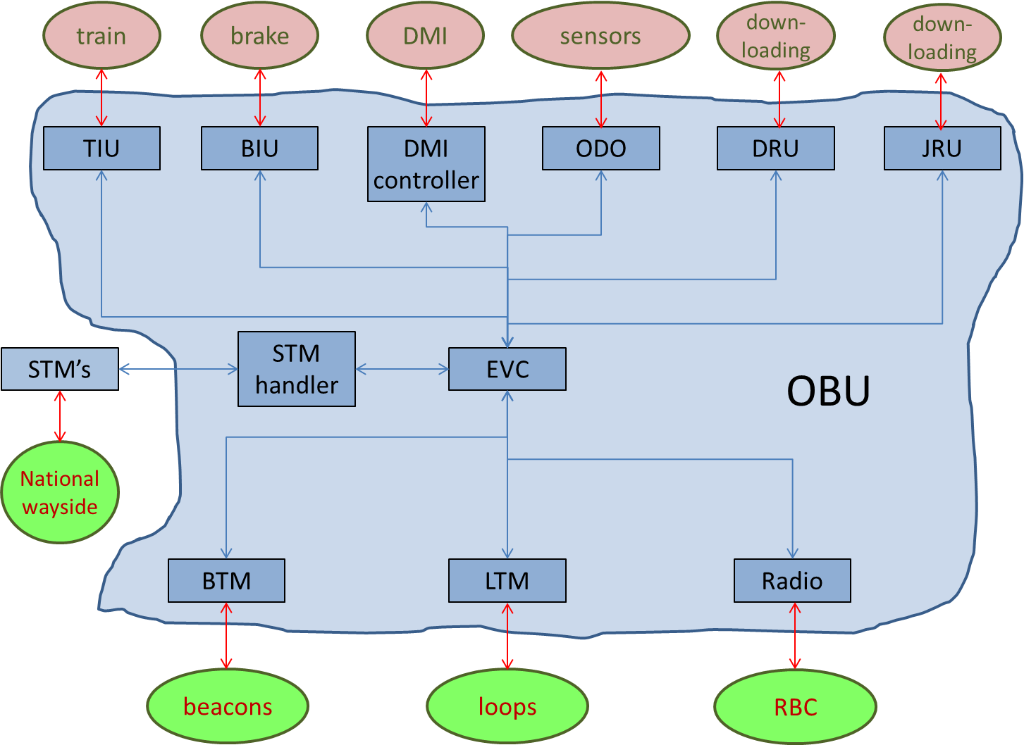

Today the OBU is the complete ETCS on board installation. The scope of openETCS is limited to the EVC, the part realizing the ETCS functionality.

In the SSRS
- the ETCS requirements have to be assigned to the EVC, the different OBU sub functions, the on board installation, the STM’s and the wayside systems
- Requirements assigned to the EVC must be clarified.
- Functions realizing the requirements have to be described including the input and output data needed (“Data dictionary”)
The input and output data can be external for the EVC (to the sub functions described above) or between internal EVC functions
- The interfaces between the EVC and the sub functions have to be described including the data format for the information exchanged: “EVC interface specification”

OBU external interfaces and their specifications:

TIU/BIU-train
- Subset 34 (FIS)

DMI controller-DMI
- ETCS Driver Machine interface ERA_ERTMS_015560

ODO-sensors
- Not defined

DRU-downloading tool
- X

JRU-downloading tool
- X

STM manager-STM’s
- Subset 35
- Subset 56
- Subset 57
- Subset 58

BTM-beacons
- Subset 36

LTM-loops/radio infill
- Subset 44
- Subset 47
- Subset 48

Radio-RBC
- subset 37

EVC external interfaces and their specifications:

EVC-TIU/BIU
- Information description in subset 34

EVC-DMI controller
- Information from ETCS Driver Machine interface ERA_ERTMS_015560

EVC-odometer
- 97E2675B

EVC-JRU
- Subset 27

EVC-DRU
- Customer specific specifications

EVC-STM manager
- Information from subset 58

EVC-BTM
- x

EVC-LTM
- x

EVC-Radio
- x

Further data descriptions can be derived from:
- subset 26, chapter 7,
- …..

EVC internal interfaces

The EVC internal interface descriptions will arise from the description of the functions and the information exchanged between them.

Therefore the SSRS will include:
- Requirements, traceable to the ERA specifications, clarified and assigned to EVC and/or sub functions
- Description of the EVC functions
- Internal and external EVC interfaces: the “Data dictionary”, and thus the internal EVC architecture.

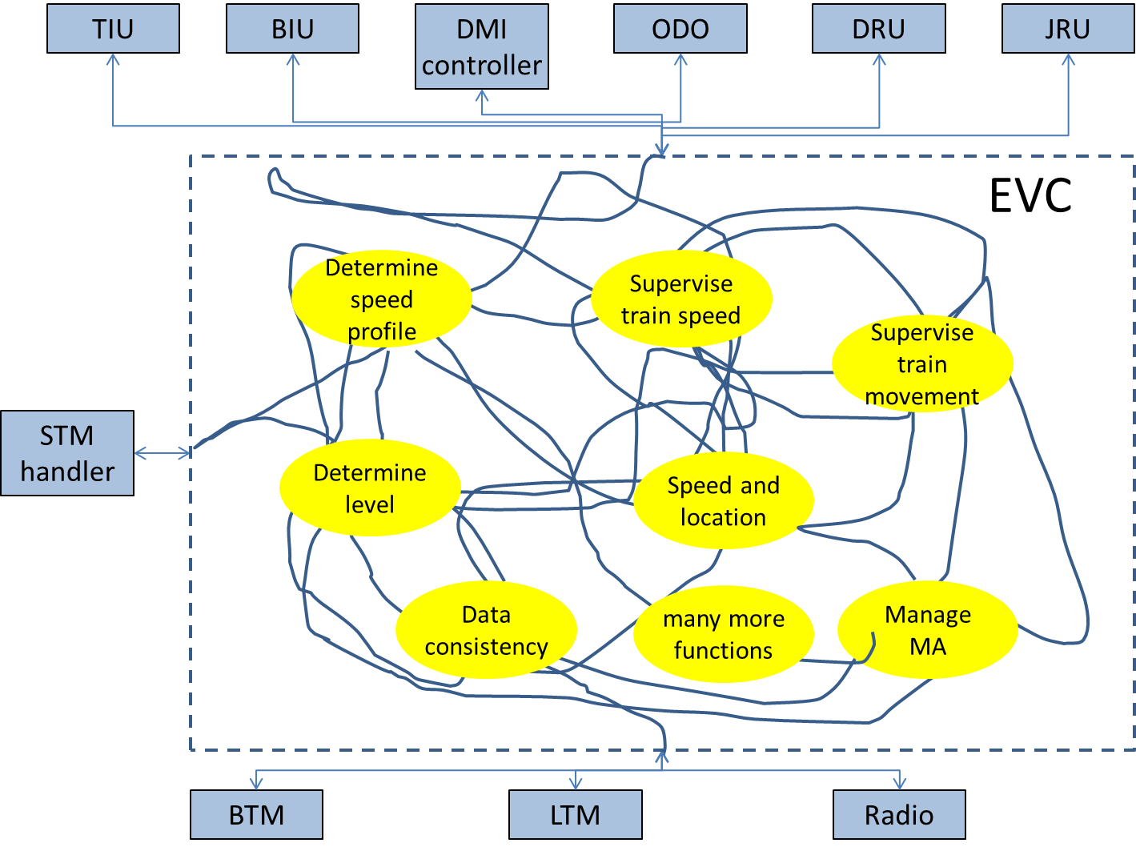
Impression of the EVC internal architecture:

